***IMPLEMENTATION OF LEXICAL ANALYZER***

***NAME:*** **RISHAL RAMESH *EXP NO:* 1**

***REG NO:* RA1911030010084**

***DATE:* 10/01/2022**

***AIM:***

To study and code a lexical analyser in any of the programming languages.

***LANGUAGE USED:***

C++

***ALGORITHM:***

* Start
* Get the input program from the file prog.txt.
* Read the program line by line and check if each word in a line is a

keyword, identifier, constant or an operator.

* If the word read is an identifier, assign a number to the identifier and make an entry into the symbol table stored in sybol.txt.
* For each lexeme read, generate a token as follows:

1. If the lexeme is an identifier, then the token generated is of the form <id, number>
2. If the lexeme is an operator, then the token generated is <op,

operator>.

1. If the lexeme is a constant, then the token generated is <const, value>.
2. If the lexeme is a keyword, then the token is the keyword itself.

* The stream of tokens generated are displayed in the console output.
* Stop.

***CODE:***

#include<bits/stdc++.h>

#include<stdlib.h>

#include<string.h>

#include<ctype.h>

using namespace std;

int isKeyword(char buffer[])

{

char keywords[32][10] =

{"auto","break","case","char","const","continue","default",

"do","double","else","enum","extern","float","for","goto",

"if","int","long","register","return","short","signed",

"sizeof","static","struct","switch","typedef","union",

"unsigned","void","volatile","while"};

int i, flag = 0;

for(i = 0; i < 32; ++i)

{

if(strcmp(keywords[i], buffer) == 0)

{

flag = 1;

break;

}

}

return flag;

}

int main()

{

char ch, buffer[15],b[30], logical_op[] = "><",math_op[]="+-*/=",numer[]=".0123456789",other[]=",;\(){}[]'':";

ifstream fin("Program.txt");

int mark[1000]={0};

int i,j=0,kc=0,ic=0,lc=0,mc=0,nc=0,oc=0,aaa=0;

vector < string > k;

vector<char >id;

vector<char>lo;

vector<char>ma;

vector<string>nu;

vector<char>ot;

if(!fin.is_open())

{

cout<<"error while opening the file\n";

exit(0);

}

while(!fin.eof())

{

ch = fin.get();

for(i = 0; i < 12; ++i)

{

if(ch == other[i])

{

int aa=ch;

if(mark[aa]!=1)

{

ot.push_back(ch);

mark[aa]=1;

++oc;

}

}

}

for(i = 0; i < 5; ++i)

{

if(ch == math_op[i])

{

int aa=ch;

if(mark[aa]!=1)

{

ma.push_back(ch);

mark[aa]=1;

++mc;

}

}

}

for(i = 0; i < 2; ++i)

{

if(ch == logical_op[i])

{

int aa=ch;

if(mark[aa]!=1)

{

lo.push_back(ch);

mark[aa]=1;

++lc;

}

}

}

if(ch=='0' || ch=='1' || ch=='2' || ch=='3' || ch=='4' || ch=='5' || ch=='6' || ch=='7' || ch=='8' || ch=='9' || ch=='.' ||ch == ' ' || ch == '\n' || ch == ';')

{

if(ch=='0' || ch=='1' || ch=='2' || ch=='3' || ch=='4' || ch=='5' || ch=='6' || ch=='7' || ch=='8' || ch=='9' || ch=='.')

b[aaa++]=ch;

if((ch == ' ' || ch == '\n' || ch == ';') && (aaa != 0))

{

b[aaa] = '\0';

aaa = 0;

char arr[30];

strcpy(arr,b);

nu.push_back(arr);

++nc;

}

}

if(isalnum(ch))

buffer[j++] = ch;

else if((ch == ' ' || ch == '\n') && (j != 0))

{

buffer[j] = '\0';

j = 0;

if(isKeyword(buffer) == 1)

{

k.push_back(buffer);

++kc;

}

else

{

if(buffer[0]>=97 && buffer[0]<=122)

{

if(mark[buffer[0]-'a']!=1)

{

id.push_back(buffer[0]);

++ic;

mark[buffer[0]-'a']=1;

}

}

}

}

}

fin.close();

printf("Keywords: ");

for(int f=0;f<kc;++f)

{

if(f==kc-1)

cout<<k[f]<<"\n";

else

cout<<k[f]<<", ";

}

printf("\nIdentifiers: ");

for(int f=0;f<ic;++f)

{

if(f==ic-1)

cout<<id[f]<<"\n";

else

cout<<id[f]<<", ";

}

printf("\nMath Operators: ");

for(int f=0;f<mc;++f)

{

if(f==mc-1)

cout<<ma[f]<<"\n";

else

cout<<ma[f]<<", ";

}

printf("\nLogical Operators: ");

for(int f=0;f<lc;++f)

{

if(f==lc-1)

cout<<lo[f]<<"\n";

else

cout<<lo[f]<<", ";

}

printf("\nNumerical Values: ");

for(int f=0;f<nc;++f)

{

if(f==nc-1)

cout<<nu[f]<<"\n";

else

cout<<nu[f]<<", ";

}

printf("\nOthers: ");

for(int f=0;f<oc;++f)

{

if(f==oc-1)

cout<<ot[f]<<"\n";

else

cout<<ot[f]<<" ";

}

return 0;

}

***PROGRAM.TXT:***

#include<iostream>

{

int a,b,c;

cin>>b>>c;

a=b+c;

cout<<a;

return 0;

}

***OUTPUT:***

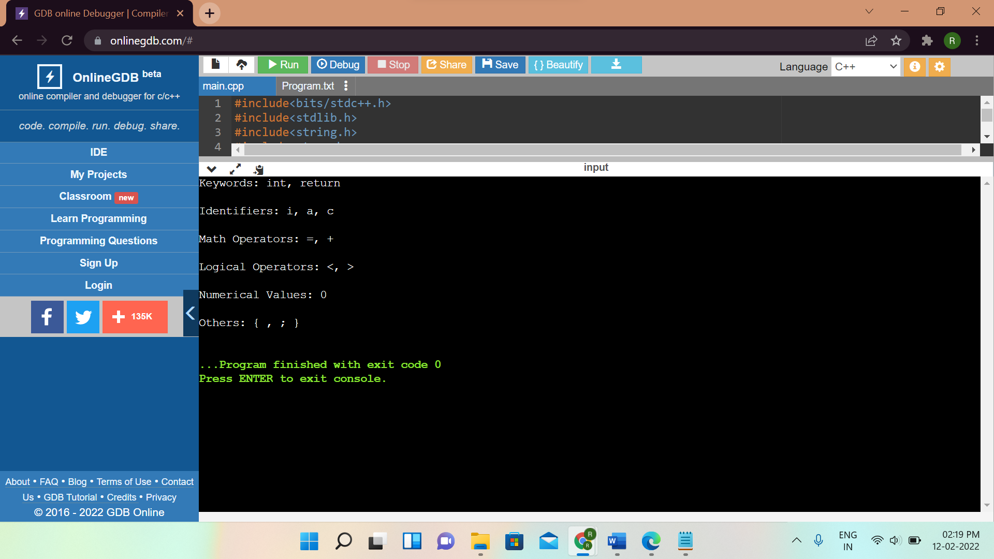

***RESULT:***

Lexical Analyser was studied and executed successfully in C++.